CPU
- Дизайн принципи в модерните компютри:

  - Всички често използвани инструкции се извършват директно от хардуера без да бъдат конвертирани в микроинструкции преди това
  - Стартиране на възможно най-много инструкции едновременно
  - Само LOAD и STORE инструкции реферират главната памет
  - Предлагане на множество регистри
- Паралелизъм на ниво инструкции
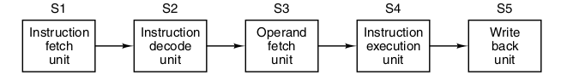
  - Pipelining – изпълнението на инструкции се разделя от предварителното им запазване (prefetching). Изпълнението на инструкции в тази концепция се разделя на дузина части, които могат да бъдат обработвани паралелно.
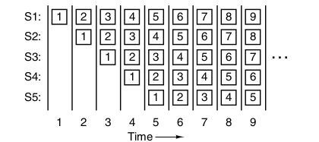
  - Trade-off between latency and processor bandwidth
  - Superscalar Architectures – multi-pipeline CPU: instruction fetch unit взима двойки инструкции и ги пуска всяка по собствен pipeline със собствено ALU
    - или компилаторът следи едната инструкция да не зависи от другата (или да ползва общи данни), или ако стане конфликт, той се изтрива. Днес се използва в CPU
    - днес терминът се използва за процесори, които издават няколко инструкции в един цикъл и имат 1 pipeline
- Паралелизъм на ниво процесор
  - SIMD (Single Instruction Multiple Data) processor – множество идентични процесори, които извършват същите инструкции, но на различни данни. Използват се в GPU
  - Vector processor – вместо няколко подпроцесора, всичко се извършва в един heavily-pipeline процесор
  - Мултипроцесори – в предишният случай нямаме същински процесори като компоненти, защото всички те се управляват от 1 control unit. Мултипроцесорите вече са няколко независими процесора, използващи същата памет
  - Мултикомпютри – системи от свързани компютри, които нямат обща памет, но всеки от тях си има собствена памет и мултипроцесор.
Cache Memory
  - Harvard Architecture – split cache for instructions and data
  - SIMM – Single Inline Memory Module 32b/cycle
  - DIMM – Dual Inline Memory Module 64b/cycle
Secondary Memory
- Memory Hierarchies
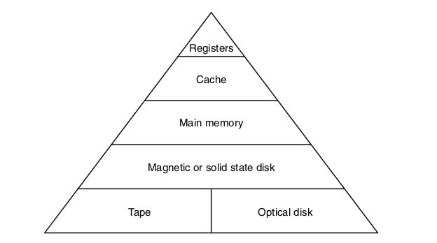
- Bus
  - Bus Arbiter – decides who goes next in the bus
  - PCI (Peripherl Component Interconnect – designed by Intel, increasingly replace by PCI Express
Gates
- Basic Gates
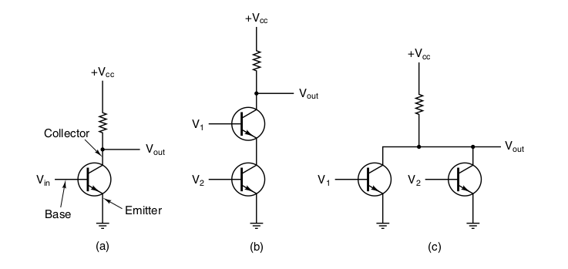
- Gate technologies
  - bipolar
    - TTL (Transistor-Transistor Logic)
    - ECL (Emitter-Coupled Logic)
  - MOS (Metal Oxyde Semiconductor) – slower than bipolar but work with lower voltage
    - PMOS
    - NMOS
    - CMOS – primarily used
- Boolean Algebra
  - Majority function
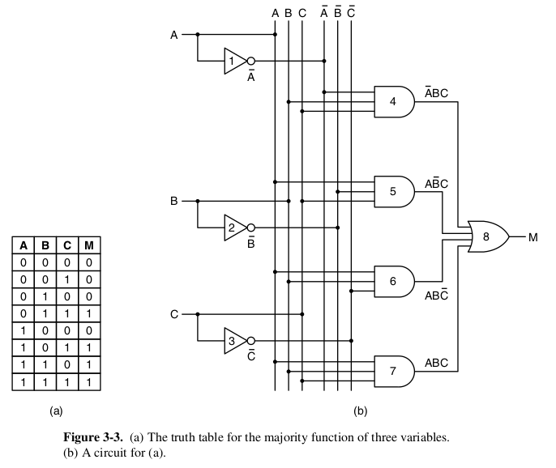
  - Implementation:
    - Write down the truth table for the function.
    - Provide inverters to generate the complement of each input.
    - Draw an AND gate for each term with a 1 in the result column.
    - Wire the AND gates to the appropriate inputs.
    - Feed the output of all the AND gates into an OR gate.
  - NAND and NOR gates are complete, because any Boolean function can be computed using either of them
- Basic Logic Circuits
  - Integrated Circuits - chips
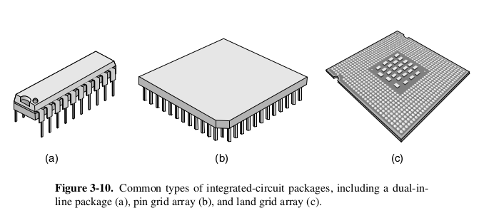
  - Combinational Circuits

    - 8-input Multiplexer
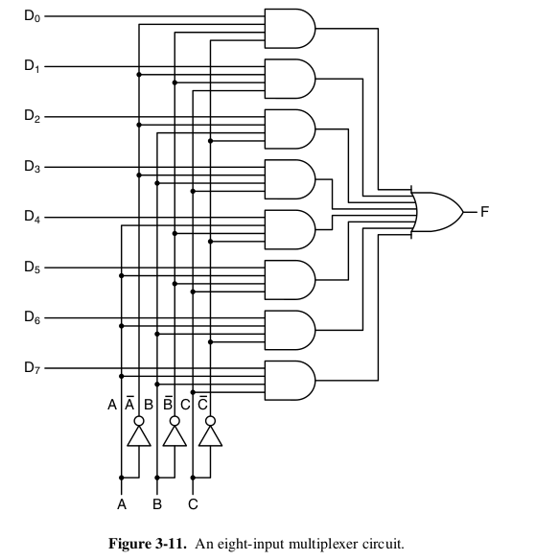
    - Decoders
    - Comparators
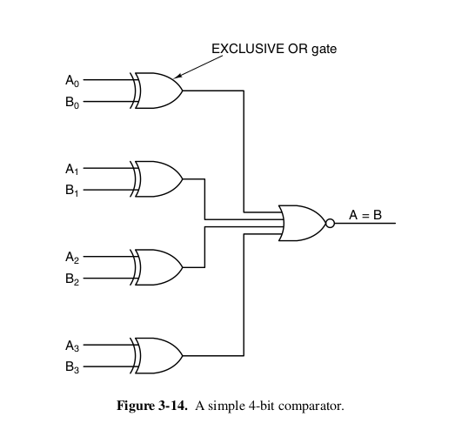
    - 1-bit ALU
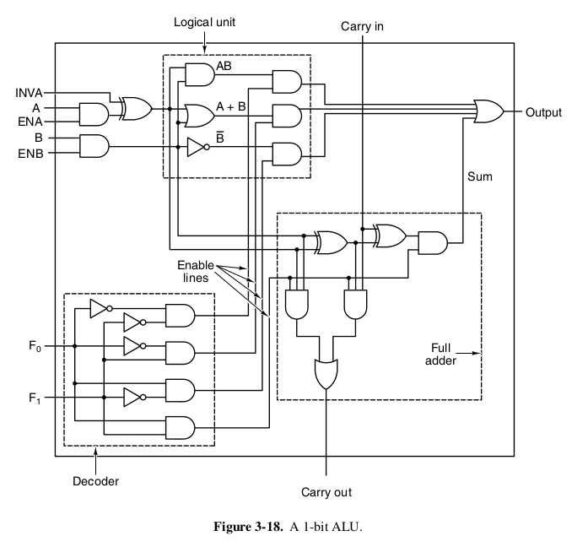
3. Clocks
- Memory
  - Latches
    - Regular – stores memory
    - Clocked SR Latch – prevents the latch from changing state except at certain times
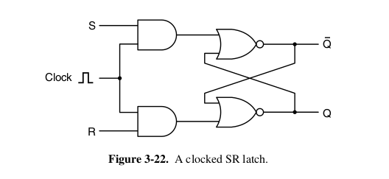
    - Clocked D Latch – resolves the Clocked latch“s instability when S=R=1 by having only one input D
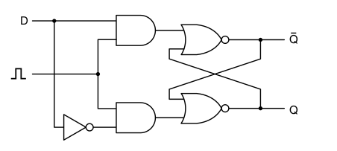
    - Flip-Flop – when it»s necessary to sample a value on a certain line at a particular instant of time and store it; the transition occurs when the clock changes from 0 to 1 or vice-versa
  - Registers – a group of Flip-Flops
  - RAM
    - SRAM – Static RAM, based on circuits like flip-flops, which is fastly accessible but stores only when there is electricity
    - DRAM – Dynamic RAM – does not use flip-flops, but cells of transistor+capacitor, which are regularly refreshed. Involves more complex interfacing but can store more. Main
    - Main memories are built of DRAM and Cache of SRAM
    - SDRAM – Syncronous Dynamic RAM, a hybrid between the two above, driven by the main system clock, thus eliminating the need for control signals to tell when the memory should respond. Instead, the CPU tells for how many cycles the memory should run
    - DDR (Double Data Rate) SDRAM – the memory produces output both on the rising and the falling edge of the clock, thus doubling the output
    - DDR2 and DDR3 – even faster
  - ROM -Read-Only Memory – cannot be changed once written
    - PROM – can be programmed once, eliminating the need for a frame of production
    - EPROM – can be erased
    - EEPROM – can be erased by implying pilses instead of exposing to UV light, can be programmed in place instead of in a special device but is smaller than EPROM and slower. Used only when non-volatility is crucial
    - flash memory – a type of EEPROM – block erasable
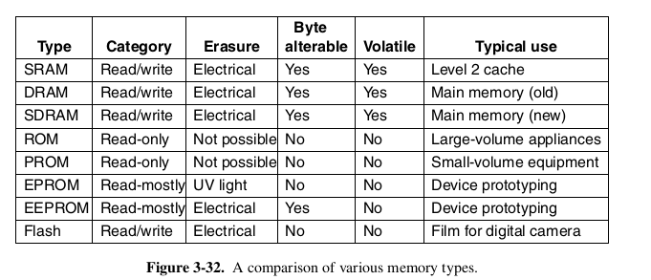
  - FPGA (Field-programmable gate arrays) – this hardware can be built in hours, rather than the months requiried for an integrated circuit IC, but requires more power and runs slower. Used for building prototypes
- CPU Chips
  - CPU contains the following pins: Address, Data and Control pins
    - The performance of a CPU is determined by the number of address and data pins. A chip with m address pins can handle 2^m memory locations. A chip with n data pins can read a n-long word in one operation. A CPU with 8 data pins will read a 32-bit word in four operations, while a CPU with 32 data pins will read the same word in one operation, but its more expensive
  - Control pins
    - Bus control
    - Interrupts
    - Bus arbitration
    - Coprocessor signaling
    - Status
    - Miscellaneous
- Computer Busses
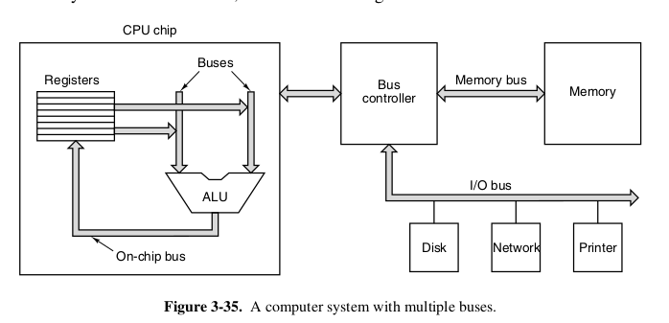
  - Famous models
    - Omnibus (PDP-8)
    - Unibus (PDP-11)
    - Multibus
    - VME bus
    - IBM PC bus (PC/XT)
    - ISA bus (PC/AT)
    - EISA bus
    - Microchannel (PS/2)
    - PCI bus (common)
    - SCSI (also common)
    - Universal Serial Bus (used today)
  - Two types of devices can connect
    - masters – active, they initiate transfers (CPU/ I/O device)
    - slaves – passive, wait for requests (Memory, I/O device, CPU rarely)
  - bus driver – controls and strengthens the flow of signals from masters
  - bus receiver – controls the signals of slaves
  - bus transceiver – for devices that can be both a master and a slave
  - Bus width – the most important design parameter
    - if a bus has n address lines, it can address 2^n memory locations
  - trade-off between memory size and cost
  - new buses require more and more address lines, thus more and more control lines as well
  - the bus also has a bandwidth that can be increased:
    - by decreasing bus cycle time (lowers backward compatibility) and causes bus skew
    - add more data lines – makes design messy
  - multiplexed bus – instead of separate address and data lines, they are used for both tasks, results in slower speed but also lower bus width and cost
  - bus clocking
    - synchronous bus – has a line, driven by a crystal oscillator
    - asynchronous bus – does not have a master clock, cycles need not be the same length
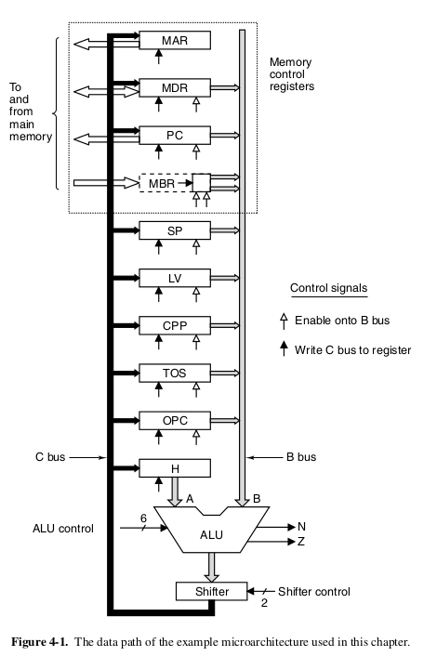
- Microarchitecture
  - Data path – the part of the CPU with the ALU, inputs and outputs
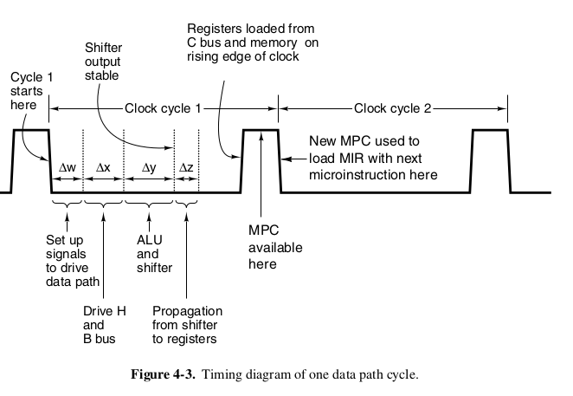

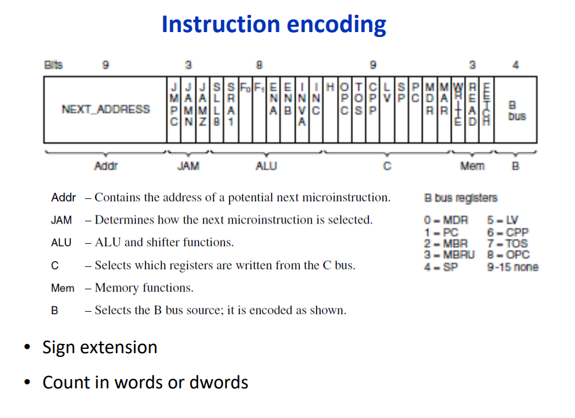

- Microinstructions
  - Processes that occur in one clock cycle and timing:
    - 1. The control signals are set up (Δw).
    - 2. The registers are loaded onto the B bus (Δx).
    - 3. The ALU and shifter operate (Δy).
    - 4. The results propagate along the C bus back to the registers (Δz)
    - 5. At the rising edge of the new clock cycle the results are stored in the registers
  - A machine has:
    - a 32-bit word-addressable memory port – controlled by MAR(Memory Address Register) and MDR(Memory Data Register)
    - 8-bit byte-addressable memory port – controlled by PC register, which reads 1 byte into the MBR, this port can only read data from memory, it cannot write
    - MAR, MDR, MBR and PC are driven by 1-2 control signals. An open arrow under a register indicates a control signal, which enables the register output onto the B bus.
    - Since MAR doesn’t have a connection to the B bus, it doesn’t have an enable signal. H also doesn’t have one because it is the only possible left ALU input and is always enabled.
    - A solid black arrow under a register indicates a control signal that writes (loads) the register from the C bus
    - Since MBR cannot be loaded from the C bus, it doesn’t have a write signal
    - MAR/MDR combination reads and writes ISA-Level data words
    - PC/MBR combination reads the executable ISA-Level program, which is a byte stream.
    - The MBR value can be copied to the B bus either unsigned or signed. That’s why two arrows are present
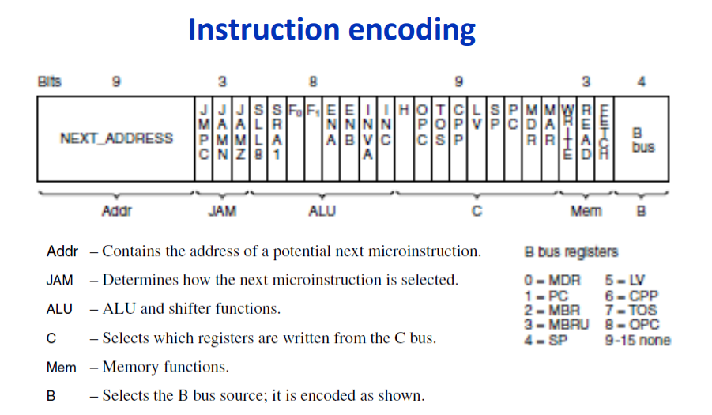
  - Microinstructions

    - data path on the left, control section on the right
    - control section has a control store- stores the microinstructions, each microinstruction explicitly specified the next, therefore they aren’t executed in order of appearance. Since the control store is functionally a read-only memory, it needs a memory address register – MPC (MicroProgram Counter), and a memory data register – MIR (MicroInstruction Register) – holds the current microinstruction
- Design of a microarchitecture
  - Speed vs cost
    - Three ways to reduce speed of execution: reduce the number of clock cycles needed, simplify the organisation, so that a clock cycle is shorter, overlap instruction execution
    - Path length – the number of clock cycles needed to execute a set of operations
  - IFU (Instruction Fetching Unit) – independently increments PC and fetches bytes from the byte stream before they are needed. That way, the ALU is relieved, the main loop is eliminated and the path length is reduced in certain situations
  - Prefetching – не разбрах
  - Pipelining – the data path is partitioned by three latches into smaller parts, thus allowing parallelism.
- Cache
  - Latency (delay) and bandwidth are at odds.
  - Different caches for data and instructions – In the CPU
  - Level 2 cache – between the instruction and data caches and the main memory – outside the CPU but connected to it with a high-speed path, generally unifies data and instructions
  - Level 3 cache – on the processor board
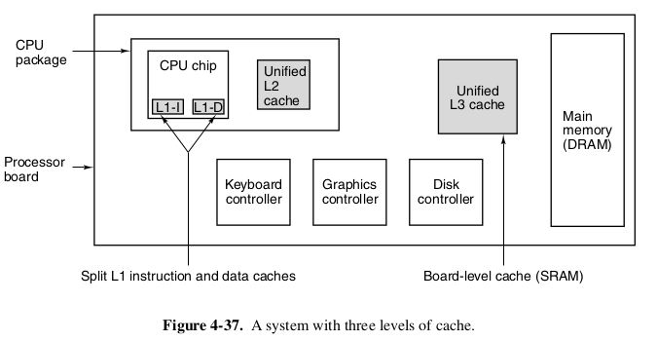
    - Direct-mapped cache – the simplest
    - Set-Associative Cache – lines constantly compete for specific cache slots in the cache. A cache that allows n possible entries for each address is called n-way set-associative cache
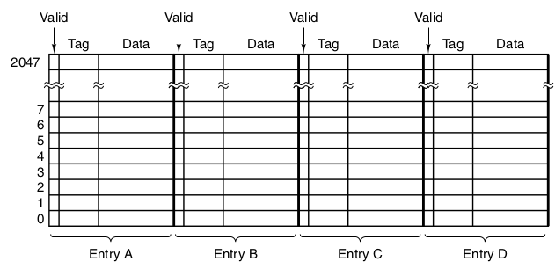
    - LRU (Least Recently Used) – an algorithm, which discards a line in a cache entry, so another more frequently used can be stored in the cache instead
    - When a processor writes a word and the word is in the cache, the cache should be updated. If the main memory is also updated immediately – write through. If the main memory is updated when the line in cache is to be replaced by another- write back.
- Addressing modes
  - Immediate addressing – can address only a constant
  - Direct addressing – gives the full address – the instruction will always access that same memory location
  - Register addressing – specifies a register rather than a memory location
  - Register indirect addressing – the operand specified comes from memory or goes to memory. The address is contained in a register and is called a pointer. It can reference memory without paying the price of having full memory address in the instruction
  - Indexed addressing – useful for referencing memory at a known offset from a register.
  - Based-Indexed addressing – one register is the base, and the other is the index for offsetting
  - Stack addressing – no addresses
- The IA-64 architecture
  - A speculative LOAD doesn’t cause an exception if it fails, but it just stops and a bit associated with the register to be loaded is set marking the register as invalid.

